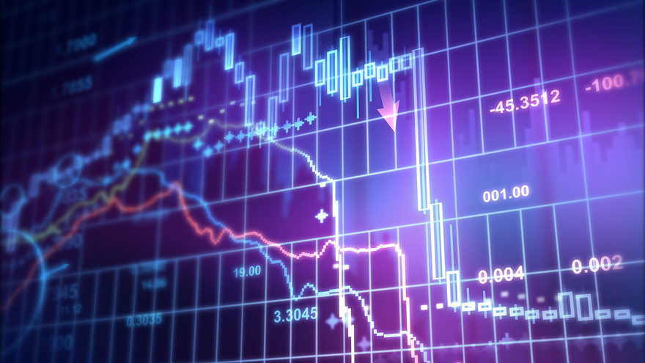

|  |
| --- |
|  |
| text dividerwhite rectangle for text on cover |
| text divider  Stock Inspector  Authored by: |

colored rectangle

1. Introduction 4

2. Collected Data 4

3. Tools of the Trade

4. Considerations

5. Overall Assessment

6. Conclusion

5

## 1.Introduction

This report summarizes the project work conducted by our team. We were given the task to conduct - throughout - the course of two weeks - to deploy an application on a chosen topic and to provide the users with interactive graphs to explore the data.

We believe that nowadays, especially younger people should be confronted with investment opportunities early on, and should be provided with simple tools to explore different investment opportunities. There exist different possibilities for people to invest, like for example investments in equity (e.g stocks), fixed income securities (e.g. bonds), real estate, commodities and more recently in crypto assets. In those different asset classes, there exists always a trade-off between the risk taken and the expected return. In our project, we decided to focus on the asset class stocks.

We suggest several intuitive visualizations for companies listed in the Fortune Global 500 ranking. Within this ranking, we only focused on stocks that would be publicly traded at either a stock exchange or “over the counter”. In line with our goal, the visualizations should provide users with limited financial knowledge the possibility to comprehend the data and the different ways on how to look at the stock data.

In this report, we provide a brief recap of the steps our group has taken to provide a user friendly application that we named “The Stock Inspector”. The final product constitutes a suite of data visualizations, which feature a number of techniques covered in the UC Berkeley Data Analysis & Visualizations Bootcamp, with a particular emphasis on user interactions.

In a fist step, we describe the data that we collected as part of this project. Second, we elaborate on the “Tools of the Trade”, meaning the data visualization tools that we deployed for our application. Third, we discuss the three different considerations that used to group the data. Those are the fundamental considerations, the technical considerations, as well as the environmental considerations. Fourth, an overall assessment on the different stock considerations is outlined. Ultimately, we summarize our project laying out the project limitations and an outlook.

## 2.Collected Data

## Our data set covers the companies listed in the Global 500 from 2005 to 2020, for a total of 171 stocks.For each stock, the data collected can be divided into the following categories:

1. Static data

This comprises of the relatively static characteristics of a stock, for instance, the business characteristics, or the corporate governance aspects of a firm.

* + Company name
  + Industry
  + Sector
  + Latitude
  + Longitude

1. Price data

Price data and other derived values fall into this category. To facilitate rendering of visual elements within web pages, we chose to compress the data into a weekly, monthly frequency and yearly values.

* + Closing prices
  + Opening Price
  + High
  + Low
  + Historical data form July 2005 to June 2020

1. Fundamental data

Fundamentals are exclusively related to the operational characteristics of a company, for instance, its

total assets and total liabilities, annual sales, and so on. For the purposes of this study the company

fundamentals are transformed into six financial ratios:

* Market capitalizations
* PE Ratio
* EPS
* Dividend Percent
* Exchange

1. Environmental data
   * ESG Score

In order, to give a holistic view of any individual stock, or the index as a whole, we would also need a way to

efficiently query the data and use the resulting subset to populate the visualizations. A key observation is that

Individual stocks can be uniquely identified by the ticker symbol; for the case of prices data the unique key would be the stock symbol and the timestamp combined; however for other cases only stock symbol is utilized. Motivated by this observation, we have chosen to store the data in a relational database-like manner. More specifically, the data set is broken down into a large number of small csv files organized into several folders, allowing our web portal to rapidly gather data across multiple data categories on user demand.

## 3. Tools of the Trade

Prototyping our visualization idea was both challenging and rewarding. Our team made good use of the mainstream web development toolkits (HTML, JavaScript, CSS, Leaflet) as well as back-end scripting languages as SQL.

### Data Acquisition

A major headwind for our project was that many types of financial data we looked for (except for prices) were not readily bundled into downloadable datasets by third parties. Instead the data was everywhere - including various finance websites targeting retail investors, plus a “database website” like Stock Data - Polygon.io‎, Quandl, and Bloomberg. To simplify matters, Yahoo Finance - the website with the largest set of historical data was available. Combining these data sources manually is simply too time-consuming to even consider. However, our team was able to extract the data manually that was needed from Global 500 and Yahoo Finance.

### Data Processing and Visualization

After collecting an initial set of data, we proceeded to build the visualization templates using the front-end technologies of choice, including HTML, JavaScript (D3.js, jQuery, and Leaflet), and CSS.

*D3.js and jQuery*

The de facto standard for data visualization, we initially made the choice to move into D3 and jQuery rather than the Plotly because we had little knowledge of these tools and would like to try out a tool that supports our preferred programming language, JavaScript.

After using D3 to create the charts for this project, we would argue that this tool has the advantages like visualizations were fully customizable and was possible to create highly interactive displays of data. Plain D3 has limited data manipulation capabilities. However, with other libraries (jQuery being the most prominent) we were able to overcome.

## 4. Considerations

### 4.1 Fundamental Considerations

### *Overview*

[Fundamental analysis (FA) is a method of measuring a security's intrinsic value by](https://www.investopedia.com/terms/v/valuation.asp)

[examining related economic and financial factors. Fundamental analysts study anything that can affect the security's value, from macroeconomic factors such as the state of the economy and industry conditions to microeconomic factors like the effectiveness of the company's management.](https://www.investopedia.com/terms/v/valuation.asp)

[The end goal is to arrive at a number that an investor can compare with a security's current price in order to see whether the security is undervalued or overvalued.](https://www.investopedia.com/terms/v/valuation.asp)

[This method of stock analysis is considered to be in contrast to technical analysis, which forecasts the direction of prices through an analysis of historical market data such as price and volume.](https://www.investopedia.com/terms/v/valuation.asp)

### 

### *Analysis*

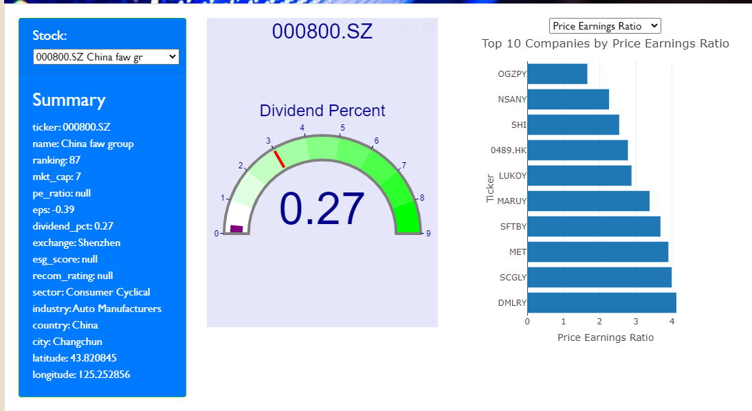

Our Stock Inspector app can rank companies based on dividends and price earnings ratio.

Dividend percent determines the percentage of the stock value an investor can receive per year. It is a solid stream of income the investor can expect to earn. Our app has a bar chart which shows the top 10 companies ranked by dividends. This is good for investors looking for periodic payouts from their stock portfolio. From our chart, we could see that Glencore, BP, and HSBC are the top three companies with the highest dividend payouts.

Price earnings (PE) ratio shows how expensive a stock is in multiples of earnings. The lower of this number the better. From our chart, we could see that Gazprom, Nissan Motor, and Sinopec have the best PE ratios. Investors looking for undervalued stocks should pick them.

### *Insights*

If we combine dividend and price earning’s ratio to pick stocks, the chance of making money should be pretty high. Perhaps one could divide his portfolio with 50% based on dividends and the other 50% based on Price Earnings ratio. One should know that these numbers should be compared with companies in the same sector and or industries. With different sectors and industries, the numbers could be quite different. For example, high PE ratio and low dividends is the norm in the Technology sector, while high dividends and low PE ratio is the norm in the Energy sector.

James

### 

### 

### 

### 

### 4.2 Technical Considerations

### *Overview*

What is Technical Analysis?

Technical analysis is the study of chart patterns and statistical figures based on historical market data to understand market trends and pick stocks accordingly. Sounds complicated? Here is a simpler definition. One day the share price is up, another day it may be down. But over time, if you look at the stock price’s movement, you may see trends and patterns emerge. The study of these chart patterns and trends in stock prices is called technical analysis of stocks. The technical analysis aims to provide a holistic view of historical changes in stocks, helping users to learn how it has grown to the currentstate, as well as gain insight in the markets through event studies. We believe that learning about the past is beneficial for users to gain a deeper understanding of the current index and further enable them to predict the future.

### *Analysis*

In order to use technical analysis for predicting stock prices, we have to assume that there is some relationship between historical market data such as price and volume. This is the only way we can meaningfully use historical data to predict future prices. Based on these assumptions we used the price and volume charts to identify the market trends. Our visualization on the historical changes in the chart are grouped by prices and volume. The scope of stocks are selected based on the historical changes in the past 5 years. The reason for limiting the period to be 5 years is that the market capitalization data in YahooFianance.com were only available for the past 5 years with a few of the monthly data are not available for several relatively small stocks that we have to conduct linear interpolation to make sure a smooth monthly transition.

There are five dimensions of data involved in this visualization and we came up with the design based on these data types and how they are usually visualized with multiple time spans (1 week, 1 month, 6 months, 1 year or 5 year)

* Stock Symbol and company name
* Closing Price
* Average Closing Price
* Time (Quantity)
* Volume(Quantity)

We built a stock chart that illustrates the movement of a financial instrument over a period of time. We broke down the various components required to render an interactive price chart that tracks a particular stock. Required components were:

* Loading and parsing of data
* SVG element
* X-time and -Y Price axes
* Close price line chart
* Simple moving average curve chart with some calculations
* Volume series bar chart
* Mouseover legend

In this interactive stock chart, the blue trend line represents the price movements over a given period of time and you can set the chart to different time frames from five years to one day.

The red trend line in the stock chart is a moving average which creates an average value based on average closing price data points and smoothing the underlying data.

In addition to the trend of the stock’s prices, the stocks trading volume is another key factor to look at when reading the stock chart. The volume bar chart is at the bottom of the stock charts and the key thing to look at is that when examining trading volume spikes(bars) of trading volume, which can indicate the strength of the trend - whether it is a high trading volume is down or up. Volume in stock indicates how many stocks have traded in exchange.

### *Insights*

In the beginning of the animation, the stock chart is user interactive means users can choose the stock symbol of the company and the chart will highlight the stock price and volume however you can append as many stock symbols of other company and side by side comparison and trend can be observed over time periods. This chart data provides a very important data and we can get lot of details from it, for example:

1. Low Volume: Low volume means there are less number of stocks traded in exchange. We should stay away from such stocks as there is a liquidity risk involved. Also such stocks do not have a good reputation hence less number of people want to trade it.
2. High Volume: Generally good stocks have high volume, which reduces liquidity risk. More people are trading these stocks indicating more people want them and more people believe that the company is good, might be going through a bad phase but still people are trading it.
3. Sudden change in volume: One of the important indicators is change in volume. If volume is increasing and price is also increasing, this is a buy signal and might predict a stock price increase the company is good to invest or will do well. If the stock’s price is decreasing and volume is increasing, this is Sell your stock signal.

### 

Tanvir

### 

### 4.3 Environmental Considerations

### 

### *Overview*

In an essay that was published in the New York Times in 1970, the US economist Milton Friedman introduced a theory titled “The Social Responsibility of Business is to Increase Its Profits.” In this essay, Friedman argued that a company has no social responsibility towards the general public, and only having a responsibility towards its shareholders. 50 years later, this statement does not seem to be as accurate anymore. In 2020, Larry Fink, the CEO of Blackrock, which is the world’s largest asset management company, wrote in a letter to CEOs from all over the world that sustainability should be the new standard for investing. By the end of 2020, all active portfolio’s and advisory strategies at Blackrock will be fully ESG integrated, which means that the managers will be held accountable for managing exposure to ESG risks.

ESG stands for Environmental, Social and Governance and generally constitute the three main dimensions of ESG scores. Those criterias have - as described above - become more important in the past years and are believed to increase further in the future, as investors become more conscious about the companies they invest in. There are many different approaches on how an ESG score can be calculated. In our project, we adopted the ESG Risk Rating from Sustainanalytics, which was available on Yahoo Finance. Sustainanalytics rate the degree to which a company's enterprise business value is at risk driven by environmental, social and governance issues. The rating employs a two-dimensional framework that combines an assessment of a company's exposure to industry-specific material ESG issues. The final ESG Risk Ratings scores are a measure of unmanaged risk on an absolute scale of 0-100, with a lower score signaling less unmanaged ESG Risk.

### 

### 

### *Analysis*

The ESG risk assessment of companies that are publicly traded cannot be neglected, as described above. This is the main reason why we included the ESG rating in our analysis for the stock data. It is emphasized again at this point that there exist different methodologies on how to construct the ESG scores. Another famous ESG rating is for example deployed by MSCI, an American finance company, who puts a high emphasis on the ESG criteria. The MSCI methodology applies a letter ranking from ‘CCC’ to ‘AAA’, with the latter providing a low exposure to industry specific ESG risks and their ability to manage those risks relative to peers.

For our analysis in the environmental considerations part, we provide two interactive visualizations. The first one provides a gauge chart with a dropdown that provides a list of the tickers and the company names. For user friendliness, the dropdown is sorted alphabetically. The user can choose a company ticker of interest and the gauge chart will provide the information on a one-dimensional scale from 0-100, depending on how high the ESG score is. Our data from Yahoo Finance lacked information one several of the 171 Global Fortune companies. Thus, the dropdown does hold less company tickers than that (see figure blow).

### 

### 

### 

### 

### 

### 

### 

### 

### 

The second graph, deployed as a bar chart, provides an relative comparison of the ESG scores of the companies that we analyzed, or rather the ones that were labeled with an ESG score. The user can interact with the visualization through hovering over the bars, which pulls up the name of the company and the ESG score. The x-axis of the graph provides the company ticker names and the y-axis the ESG score range from 0 to 71. We did not extend the range to 100, since the highest ESG score in our portfolio was 71 (see figure below).

### 

### 

### 

### 

### 

### 

### 

### 

### 

### 

### 

### 

### 

### *Insights*

The environmental considerations and the corresponding two interactive visualizations provide the user with means to discover the ESG score of each company on which we had data on. The insights that could be generated from the visualizations is that - contrary to expectations - certain companies show a higher ESG than others. We expected companies operating in the energy sector (especially the oil sector) to have a very low ESG score. However, the company Oil & Natural Gas shows a ESG of 51, which is the second highest value in our portfolio. This is due to the fact that the ESG methodology applied by Sustainanalytics does not necessarily rate the environmentally friendliness a company, but rather how they mitigate sector specific risks. This means that, given the sector Oil & Gas operates, they mitigate their risk well enough to reach a ESG of 51.

The analysis also showed in the relative comparison in the second graph a gradual difference between the different ESG scores of the stocks. One stock that stands out is Tokyo Electric Power, with a ESG score of 71. The difference to the second highest ESG score is 20 points.

## 

## 5. Overall Portfolio Representation

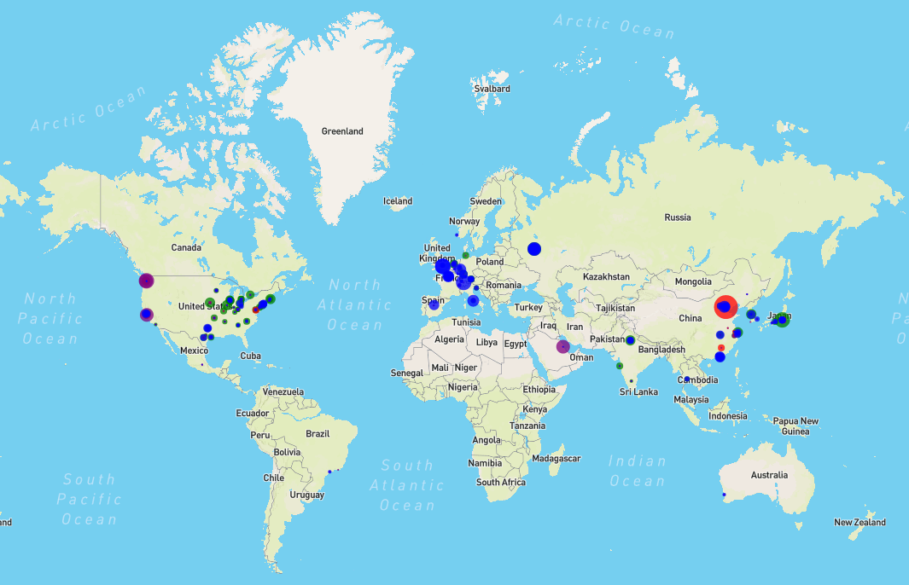

Overall, we were successfully able to pick a very diversified stock portfolio, which provides options for all types of investors. This can be visualized through the world map which represents our global footprint and where there is opportunity for each type of investor.

For the low risk tolerance investor, we provide a plethora of stock options that pay a steady dividend. This can be visualized within the map by looking at the blue circles. For example, in terms of geography, the EU is the most concentrated in providing steady dividends, which are usually a higher overall percent of the stock value.

For the high risk tolerance investor, we provide options for investing in companies with a higher P/E ratio, wherein you pay more for each dollar of earnings but aim for higher overall profits. This is represented in our map with a red circle, the highest P/E ratio is provided by JD.com in China which is the biggest ecommerce and internet company by revenue in the world.

We also provide visualizations on Market Cap (purple), ESG scores (green) and general information in the popup for each of the companies that are in our portfolio such as Sector, so the investor can make well rounded decisions.

Nicky

## 

## 6. Conclusion

In conclusion, we were able to successfully deploy our “Stock Inspector” App following the required parameters. Throughout this process we were able to yield various types of significant data associated with the Stocks 5 year performance. Under the Stock’s “Static” and “Price” data, we displayed information such as *Capital Gain*, *PE Ratios*, *and Dividend Return*, and even the location of the company’s headquarters. In addition, we included the operational characteristics of a company and its impact on the environment under the “Fundamental” and “Environmental” data. Using this information we utilized various programs to illustrate the data visualizations located in our application. Pulling from “Yahoo Finance’s” stale and monotonous display of stock data, we were able to display critical information in an improved dashboard capable of distributing investment data to users in a one-in-all application.

### 6.1 Limitations

We were faced with numerous limitations during this project. Foremost, gathering data proved to be difficult without an active “Yahoo Finance” API available. As a result, we had to mine data manually and individually. This yielded the dataset we used for our project ranging only the top 171 Stocks in the Global 500 Companies. In addition, we had issues integrating individual portions of programming code to our master file. By collaborating and revising work, we were successful in merging foreign code to follow suit with our master file.

### 6.2 Outlook

With additional time we would prioritize deploying a mobile phone app. This would result in a boost of new active users utilizing our “Stock Inspector” for their investing needs. We would also fine-tune our website to appeal to a broader audience with a greater user friendly display. Given time, the “Stock Inspector” has the potential to grow and become one of the most popular Investing apps out there.

Paul